**Menu Project Outline:**



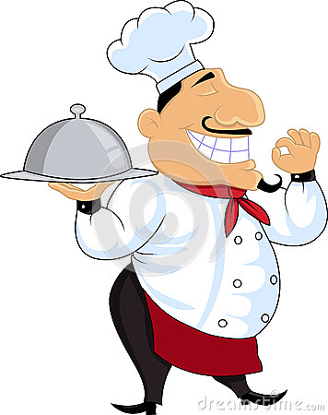

You have been giving unlimited funds and asked to create a new restaurant. You are in complete control of the look, menu, style and food selections.

However, there is a catch…..In order to receive the money to start a new restaurant you have to prove it is healthy and will help people to maintain a healthy lifestyle. Recall what we have learned about nutrients and eating disorders. We want to create healthy food that tastes good!!!

**Directions:** Create your own menu for your restaurant. The rubric you will be graded with is attached. Only the menu will be turned in for a grade. The menu can be done using whatever computer software you are comfortable with. ( Word, excel, publisher,etc) * Look at some menus to get ideas

You will be creating a menu for a restaurant run by you.

* List at least 3 different categories of food (starters, appetizers, sandwiches, soups, desserts, dinners etc.)
* List 3 options per category (at least three different food choices)
* Everything must be healthy (No fried foods! Think about clean meat!!)
* You will list how it is cooked ( grilled, bakes, steamed etc)
* You will list calories ( per serving!)
* You will list the price

**Make your menu as appealing as possible to the eye.**

**Rule #1 in Culinary: You eat with your eyes first.**

N. T. Middle School Name:_________________________

Brainstorming Worksheet for your restaurant

**Front Page of Menu**

1. 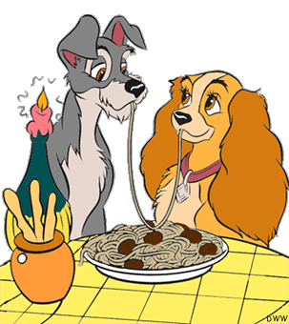**Name of restaurant**
2. **Slogan or quote relating health and food**
3. **Type of food served and style of restaurant**

Helpful Hints

Café Style  
A café is a restaurant that does not offer table service. Customers order their food from a counter and serve themselves. A café menu traditionally offers things such as coffee, espresso, pastries and sandwiches. Cafes originated in Europe and are strongly associated with France. They are known for their casual, unhurried atmosphere. Outdoor seating is another trademark of a café. Panera Bread is an example of a popular bakery-café chain. The term bistro is sometimes interchanged with café. A bistro is actually a café that offers full meals (albeit, cheaper than a full fledged sit down restaurant).

**OR**

Restaurant Style

Table service provided. Sit down menu is served with a wait staff.

Types of Cuisine

Italian, Greek, American, Spanish

Mexican, French, Korean, Vietnamese

Chinese, Mediterranean, Cajun

Japanese, Soul Food, German, Cuban

Thai, Irish, Polish, Russian, Jewish

Indian, Raw, Vegetarian

How Will the food be cooked?

* Deep Fry
* 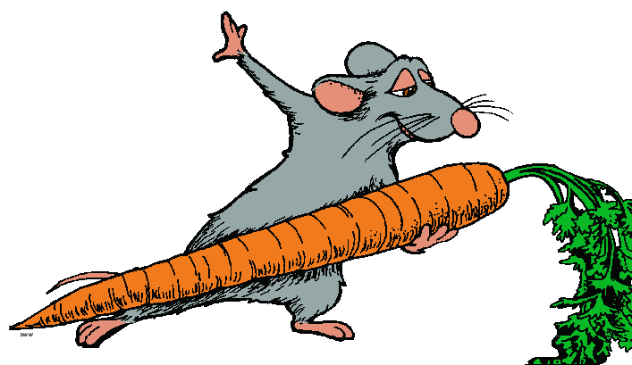Pan Fry
* Boiled
* Baked
* Steamed
* Grilled
* Brick Fire Oven
* Flat Top Grill
* Raw

**Brainstorm Area for front page**

**Inside of Menu**

1. **Pictures ( does not have to be of every item)**
2. **Categories * Must have at least three**
3. **Food selections * at least 3 per category**
4. **How each category is cooked. ( see above )**
5. **Calories in each item ( research nutrition online)**
6. **Ingredients; what is in each item.**

Helpful Hints

Food Categories  
Appetizers, Starters, Soups, Salads, Sushi Bar, Salad Bar, Main Entrée, A la carte items, Dinner for two, Desserts

Food Selections  
Any type of food that you would like. Remember, it must be healthy. Almost all foods if prepared right could be on your menu.

Ingredients  
List what makes that food special. Hook the reader into reading about that dish. You do NOT need to list ingredients for food that are self explanatory. Example: Split Pea soup. You do not need to tell us it is made from peas.

**Brainstorm Area for Inside**

**Backside of Menu**

1. **History of Restaurent**

History  
Make it interesting. Allow people to read about why your restaurant is a healthy choice for them. What makes your restaurant different from others!

HOOK the reader, HOOK the eater!

**Brainstorm Area for Backside**



**Menu Outline/ Rubric**

Name:_______________

Period:_______________

Front Page (10 Points)__________/10

(Make sure it catches someone attention )

* Name of restaurant (2.5 points)
* Slogan or quote that ties in health and food (5points)
* Type of food (2.5 points)

Inside of Menu (20 points)__________/20

* List of food options available
* Pictures(Does not have to be of every item) (1point)
* Categories * at least three (2 points)
* Food Options * at least three per category(5 points)
* How they are cooked (2 points)
* Calories & Price for each item (5 points)
* Ingredients (5 points)

Backside Of Menu (10 points)__________/10

* History of restaurant and why creating a healthy menu was so important to the owner (10 points)

Total ______/40= _______%